Standard Operating Procedure
Step-by-Step Workflow Documentation

Step 1: Step 1
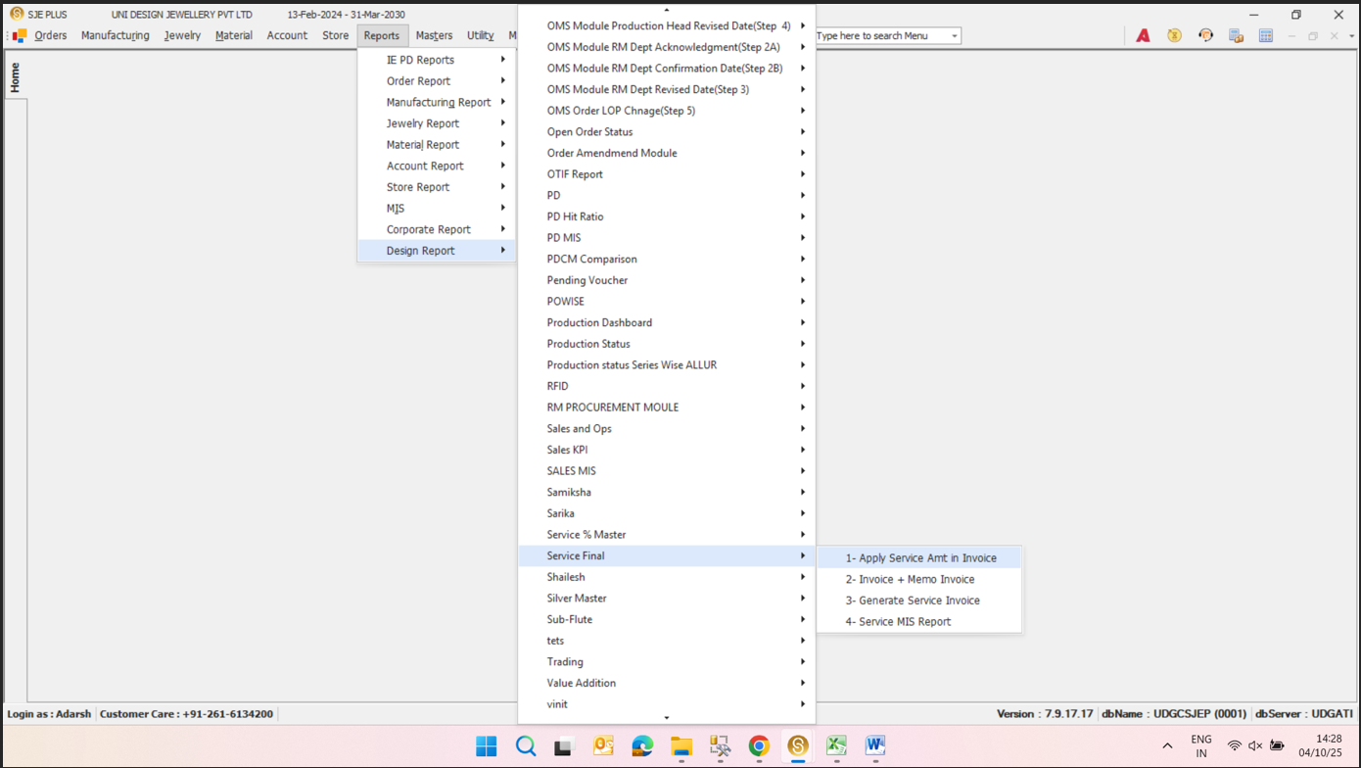
"1- Apply Service Amt in Invoice"
Key objects & actions:
- "1- Apply Service Amt in Invoice" —
- "2- Invoice + Memo Invoice" —
- "3- Generate Service Invoice" —
- "4- Service MIS Report" —

Step 2: Step 2
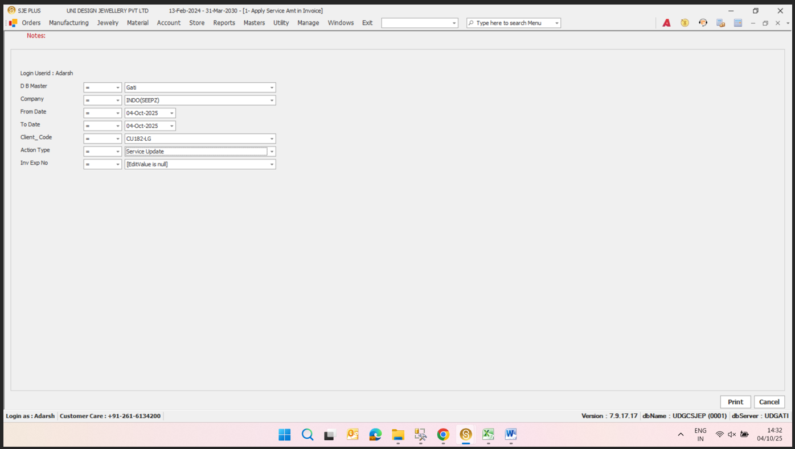
**Login User**
Key objects & actions:
- **Login User** — Adarsh
- **DB Master** — Adarsh
- **Company** — INDO(SEEPZ)
- **From Date** — 04-Oct-2025
- **To Date** — 04-Oct-2025
- **Client Code** — CU1824G
- **Action Type** — Service Update
- **Inv Exp No** — [Edit Value is null]

Step 3: Step 3
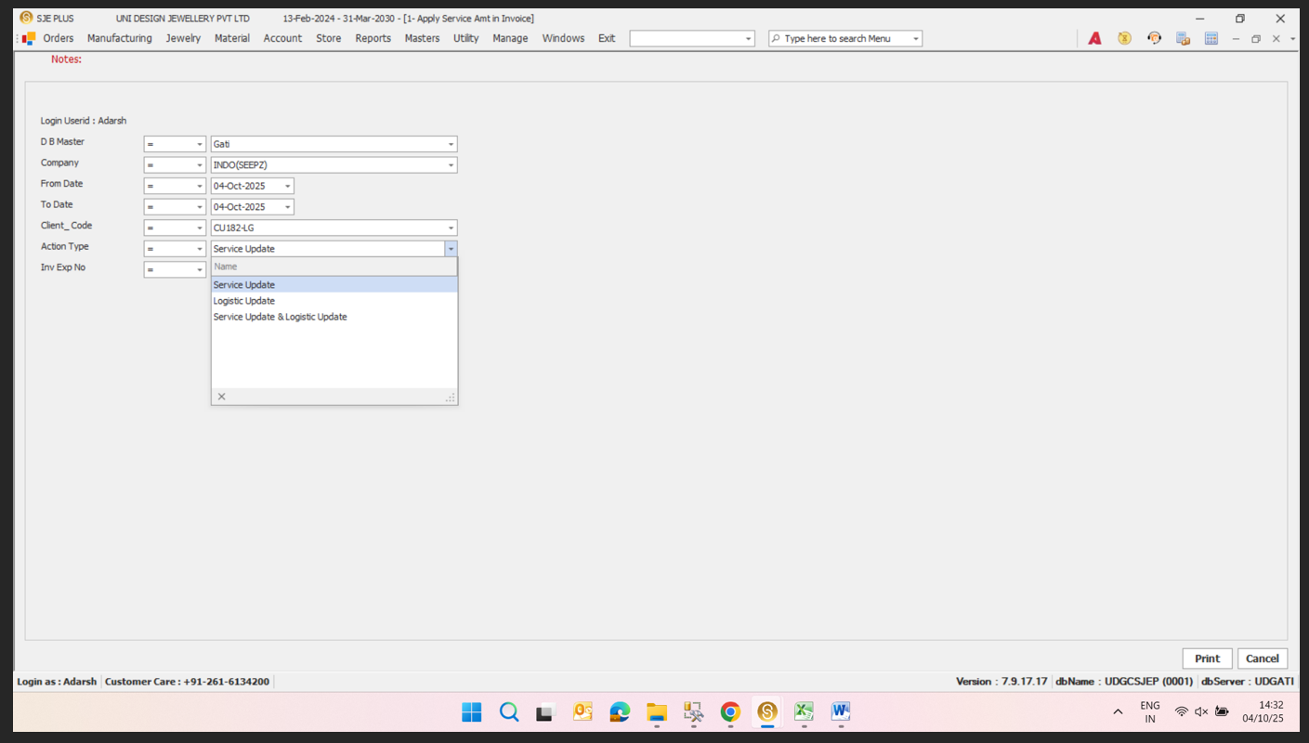
Service Update
Key objects & actions:
- Service Update —
- Logistic Update —
- Service Update & Logistic Update —

